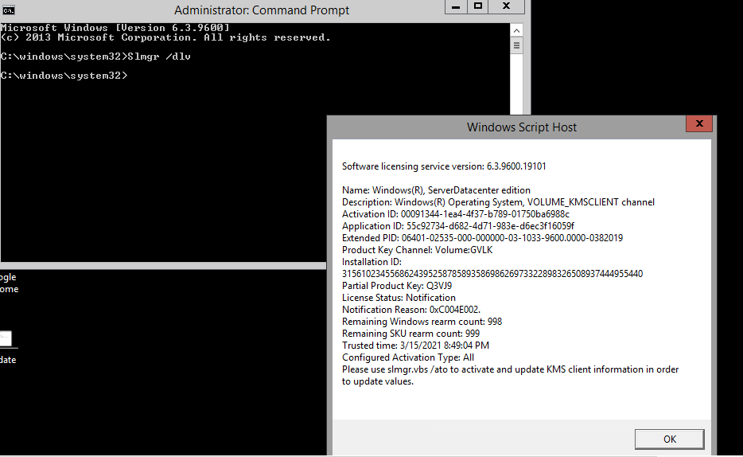

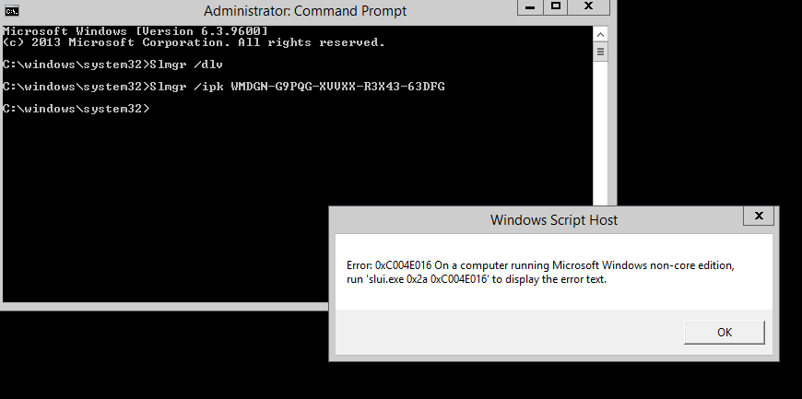

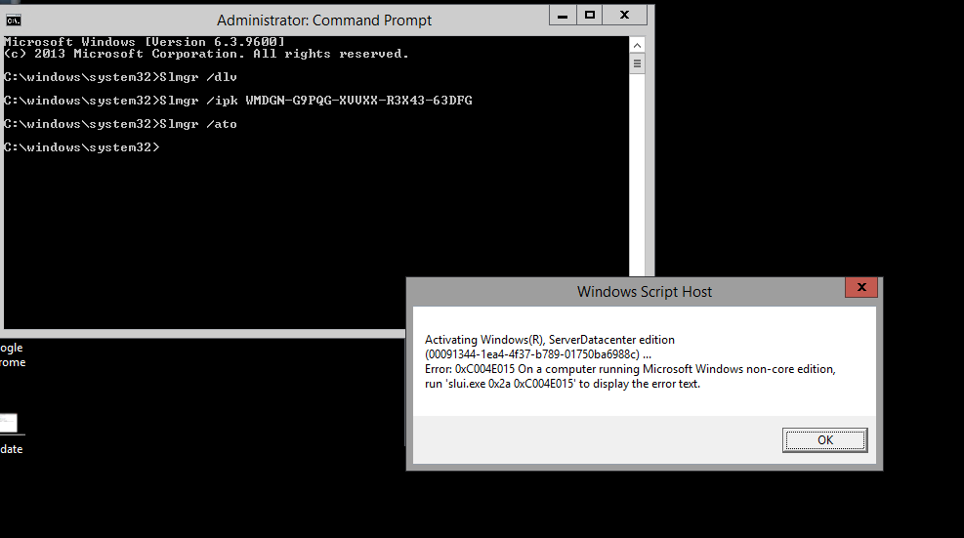

Important command

Slmgr /dlv

Slmgr /ipk <KMS client setup key>

For KMS Client setup key- please find below link.
KMS client setup keys | Microsoft Docs

Slmgr /ato

Psping kms.core.windows.net:1688

Slmgr /ckms

iex "$env:windir\system32\cscript.exe $env:windir\system32\slmgr.vbs /skms kms.core.windows.net:1688"

Slmgr /ato

Slmgr /upk

